Experiment 8.1.1: Multiplication ofi Two Square Matrices

Aim
To design and implement a Python program that performs the multiplication of two square matrices of dimension 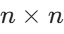. The program takes the dimension and the elements of both matrices as input from the user and computes their product.

Pseudocode

START
  - PRINT "dimension: " and READ an integer from the user, storing it in the variable n.
  - PRINT "first matrix:" and INITIALIZE an empty list A.
  - FOR each row i from 0 to 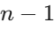:
    - READ space-separated integers from the user, convert them into a list, and append to A.
  - PRINT "second matrix:" and INITIALIZE an empty list B.
  - FOR each row i from 0 to :
    - READ space-separated integers from the user, convert them into a list, and append to B.
  - INITIALIZE a result matrix of size  filled with zeros.
  - FOR i in range n (iterating through rows of A):
    - FOR j in range n (iterating through columns of B):
      - FOR k in range n (iterating through rows of B):
        - ADD the product of A[i][k] and B[k][j] to result[i][j].
  - PRINT "Resultant Matrix:".
  - FOR each row r in the result matrix:
    - PRINT the elements of r separated by spaces.
  - END

Flowchart
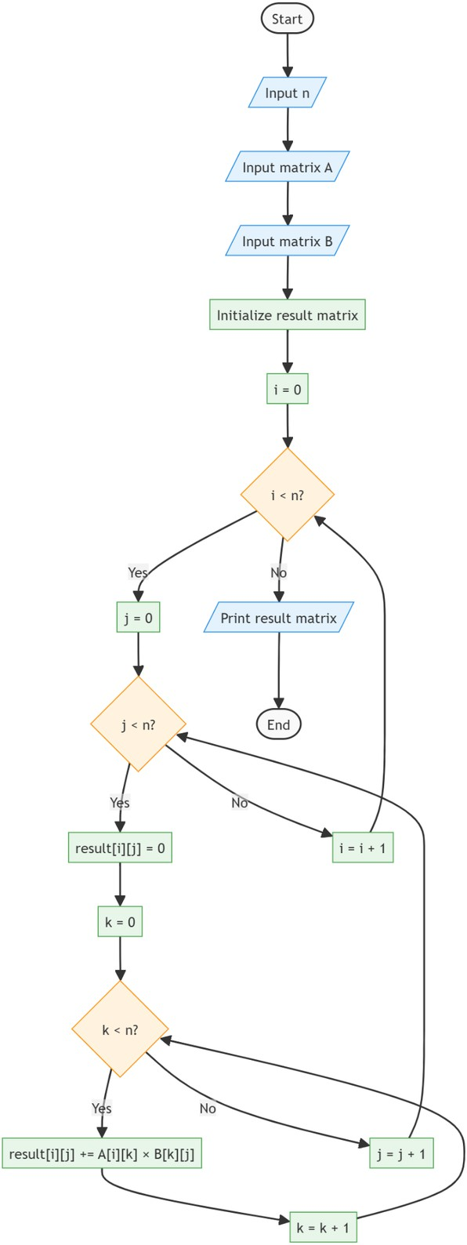
CODETANTRA:

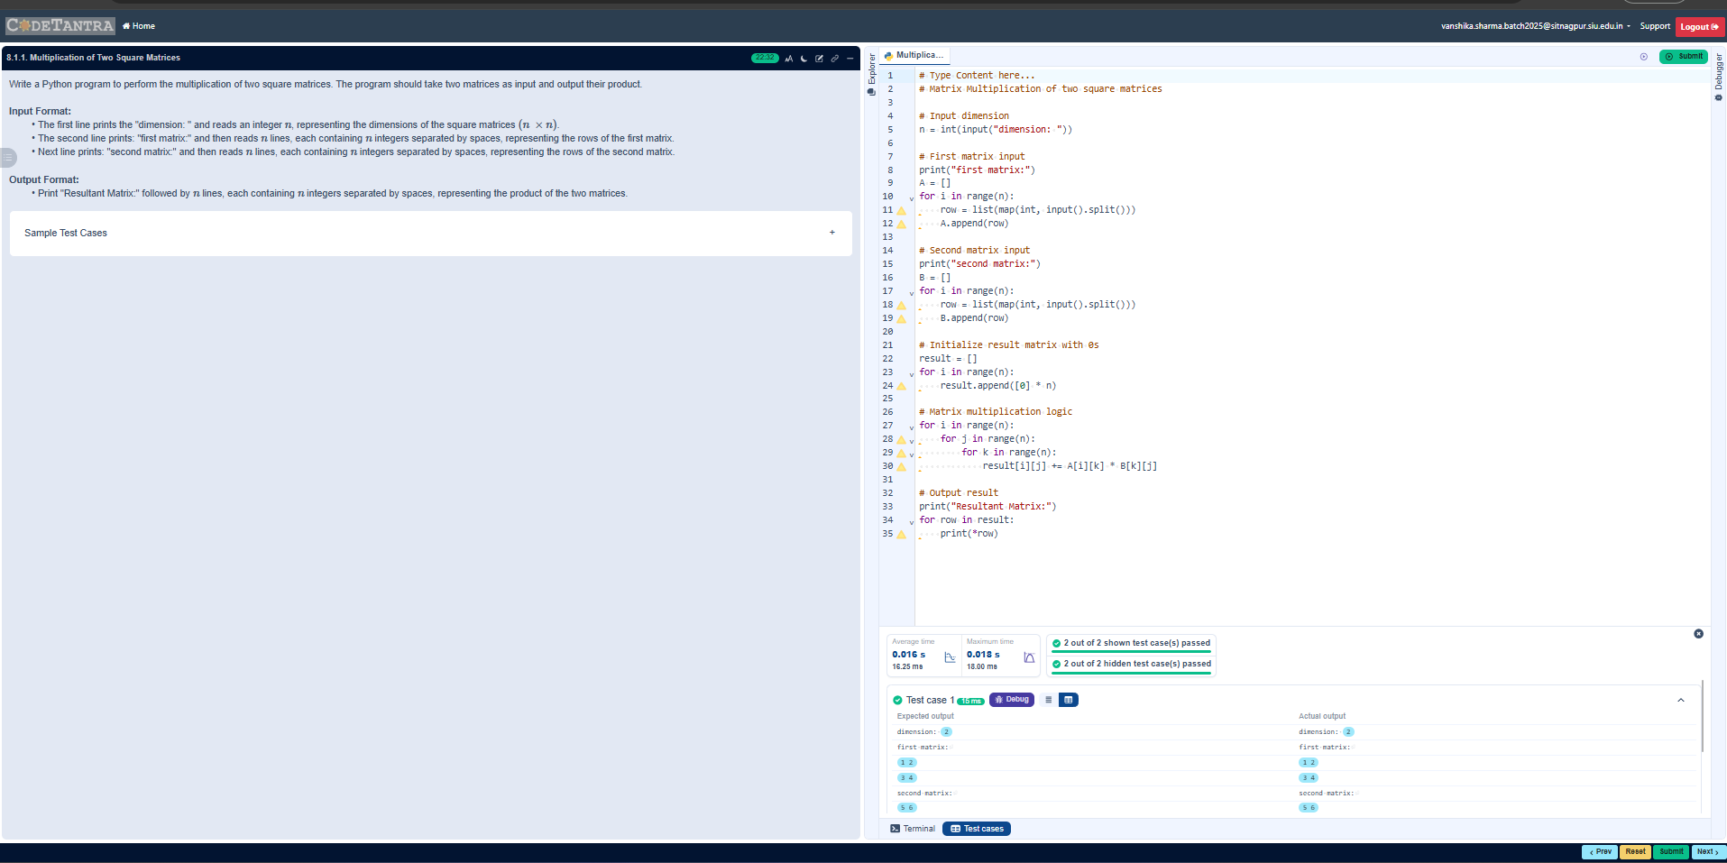Experiment 8.1.2: Prime Numbers in a Given Range

Aim
To design and implement a Python program that finds and prints all prime numbers within a specified range [start, end] (inclusive). The program determines the primality of each number and prints it. If no prime numbers exist within the given range, the program prints "No primes".

Pseudocode

START
  - READ an integer representing the start of the range and STORE it in start.
  - READ an integer representing the end of the range and STORE it in end.
  - INITIALIZE a boolean variable found to False.
  - FOR each number num in the range from start to end (inclusive):
    - IF num > 1:
      - INITIALIZE is_prime to True.
      - FOR each number i from 2 up to the integer square root of num (
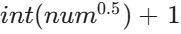 ):
        - IF num is divisible by i (num % i == 0):
          - SET is_prime to False.
          - BREAK the inner loop.
      - IF is_prime is True:
        - PRINT the prime number num.
        - SET found to True.
  - IF found is False:
    - PRINT "No primes".
  - END

Flowchart

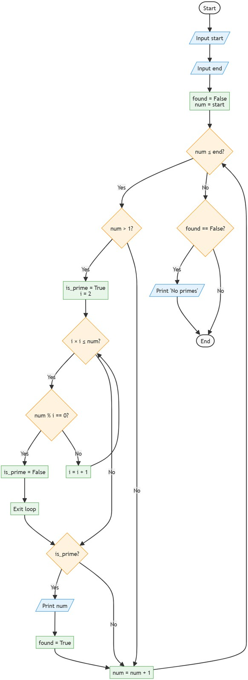
CODETANTRA:
